

Aria Workflow Test Execution Document

WFLLA-17(XML Statement Processing)

## *Phase 1 :* Custom XML Section – Paystub

*Prepared By: Chitra Singh*

*Execution date : 3/FEB/2023*

Use case 2: As a user, I want to verify the below Custom fields are populated in enhanced XML File, when the Account has no payment method, NTG is English and acct_supp_fields contains “Paper Billing”. 2

Use case 3: As a user, I want to verify the below Custom fields are populated in enhanced XML File, when the Account has Tokenised credit card as the Primary payment method, NTG is English and acct_supp_fields contains “PDF”. 5

7

# Use case 1: As a user, I want to verify the below Custom fields are populated in enhanced XML File, when the Account has no payment method, NTG is English and acct_supp_fields contains “Paper Billing”.

XML Section – Paystub

1)ps_auto_flag_hd - False

2)ps_cust_typ - B2C

3)ps_cust_class - Blank

4)ps_lang_flag - English

5)ps_print - True

6) ps_att_name - Blank (for future release) 7)header_agreement_id - Blank (for future release) 8)header_invoice_number - Blank (for future release) 9)header_po_number - Blank (for future release)

|  |  |
| --- | --- |
| Action | Details |
| Pre-Conditions | Input XML Statement File with below preconditions  Create an account with below parameter 1)Account no payment method 2)Template name is "LLA XML Template English” 3)supp_field3 contains “Paper Billing” 4) Balance forward amount applied on account |
| WF Server | us-df02 |
| Instance | LLA_DF01 |
| Test Data |  |
| Test Steps |  |
| 1 | 1. Create an account using “create_acct_complete_m” API call in LLADev with below details: 1)Account no payment method 2)Template name is "LLA XML Template English”   3)supp_field3 contains “Paper Billing”  4) Balance forward amount applied on account  Aria core will upload the XML Statement to LLA SFTP |
| 2 | Login to the below work-flow instance,  <https://us-df02.workflow.ariasystems.net/bpa/LLA_DF01/>   1. Navigate to XML Statement Dashboard and run Process File – Main flow   Enhanced XML Statement file will be generated |
|  | Expected Result: <ps_auto_flag_hd>False</ps_auto_flag_hd>  <ps_cust_typ_vrb>B2C</ps_cust_typ_vrb>  <ps_lang_flag_vrb> English</ps_lang_flag_vrb  <ps_print_vrb>True</ps_print_vrb> |
|  | Actual Result: <ps_auto_flag_hd>False</ps_auto_flag_hd>  <ps_cust_typ_vrb>B2C</ps_cust_typ_vrb>  <ps_lang_flag_vrb> English</ps_lang_flag_vrb  <ps_print_vrb>True</ps_print_vrb> |
| Comments | ***PASS*** |
| Account_No | ***33265876*** |
| Input file |  |
| Enhanced XML Output file |  |

Ps_auto_flag_hd

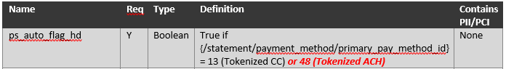

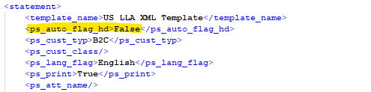

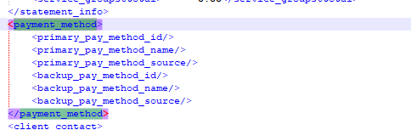

2)ps_cust_typ 3) ps_cust_class 4) ps_lang_flag

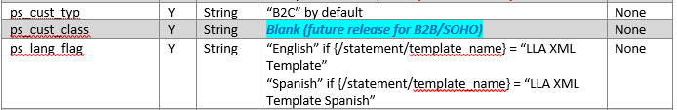

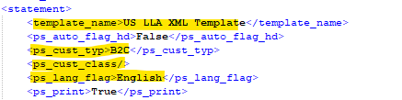

5) ps_print



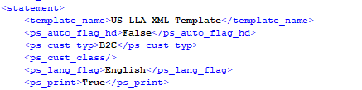

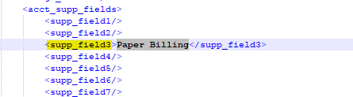

# Use case 3: As a user, I want to verify the below Custom fields are populated in enhanced XML File, when the Account has Tokenised credit card as the Primary payment method, NTG is English and acct_supp_fields contains “PDF”.

XML Section – Paystub

1)ps_auto_flag_hd - TRUE

2)ps_cust_typ - B2C

3)ps_cust_class - Blank

4)ps_lang_flag - Spanish

5)ps_print - FALSE

6) ps_att_name - Blank (for future release) 7)header_agreement_id - Blank (for future release) 8)header_invoice_number - Blank (for future release) 9)header_po_number - Blank (for future release)

|  |  |
| --- | --- |
| Action | Details |
| Pre-Conditions | Create an account with below parameter  1)Account has CC primary payment method  2)Template name is “LLA XML Template Spanish” 3)supp_field3 contains “PDF”  4)primary_pay_method_id = "13" |
| WF Server | us-df02 |
| Instance | LLA_DF01 |
| Test Data |  |
| Test Steps |  |
| 1 | Create an account using “create_acct_complete_m” API call in LLADev with below details  1)Account has CC primary payment method  2)Template name is “LLA XML Template Spanish” 3)supp_field3 contains “PDF”  4)primary_pay_method_id = "13"  Aria core will upload the XML Statement to LLA SFTP |
| 2 | Login to the below work-flow instance,  <https://us-df02.workflow.ariasystems.net/bpa/LLA_DF01/>   1. Navigate to XML Statement Dashboard and run Process File – Main flow   Enhanced XML Statement file will be generated |
|  | Expected Result : <ps_auto_flag_hd>TRUE</ps_auto_flag_hd>  <ps_cust_typ_vrb>B2C</ps_cust_typ_vrb>  <ps_lang_flag_vrb> SPANISH</ps_lang_flag_vrb  <ps_print_vrb>False</ps_print_vrb> |
|  | Actual Result: <ps_auto_flag_hd>TRUE</ps_auto_flag_hd>  <ps_cust_typ_vrb>B2C</ps_cust_typ_vrb>  <ps_lang_flag_vrb> SPANISH</ps_lang_flag_vrb  <ps_print_vrb>False</ps_print_vrb> |
| Comments | ***PASS*** |
| Account_No | ***33265625*** |
| Input File |  |
| Enhanced XML Output file |  |

1) ps_auto_flag_hd



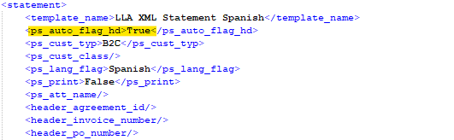

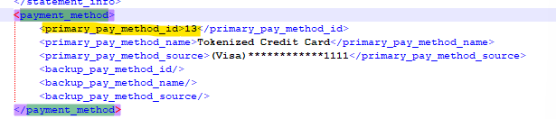

2)ps_lang_flag

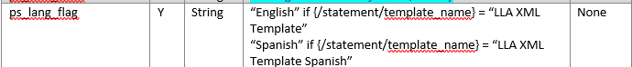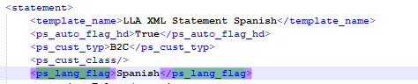

3)ps_print

# 

